18th Truro Beavers

Updated August 2021
Welcome to 18th Truro Beavers!
The Leaders at 18th Truro are Chatter and Keeo. Sometimes other leaders visit to help out and to get to know the Beavers.
At Beavers we like to do lots of different things sometimes we are inside and sometimes we are outside. We play games, make things and have fun with friends.

18th Truro Beavers
When Beavers join they are put in a small group called a lodge. Each lodge has a lodge leader, who helps to look after the younger and new Beavers.
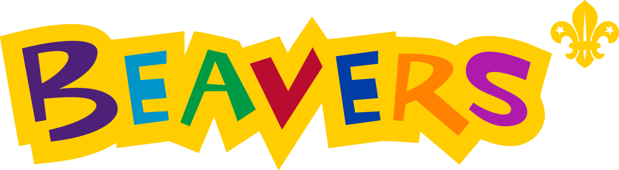
When Beavers starts there will be an activity to join in with while we are waiting for everyone to arrive. Then Chatter says ‘Riverbanks’, each Lodge has a corner of the room and your lodge leader will help you to go to the correct corner. When the lodges are quiet Chatter says ‘Build a dam’ and then the lodge leaders lead the Beavers to stand in a rectangle, ready for the register.
Each lodge at 18th is named after a ship (because we are part of a Sea Scouts group) and each ship has a treasure chest to collect their points in.
Beavers can earn golden coins for doing their best, being kind, helpful, and these are placed in their lodge chest. Each week the leaders choose a lodge who has worked well together to award a crystal for their chest. A crystal is worth 5 points. The points are added up each term and the members of the lodge with the most points receive a small reward.

Choose which promise you would like to make.
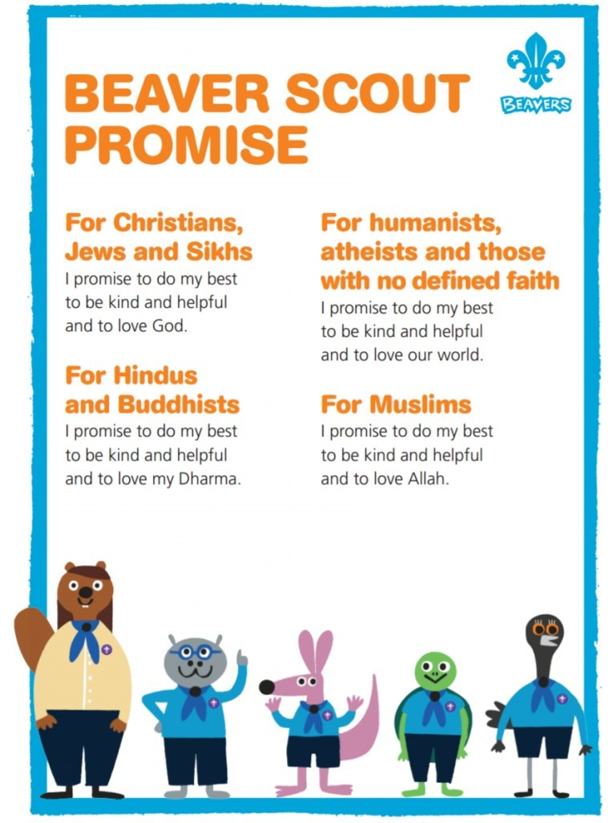

The Scout salute is
made with the right
hand and looks like
this.

Have a practise at
home.

Beavers shake hands
with their left hand.

Can you find out why?

Have a look at the Beaver motto, what do you think it means?

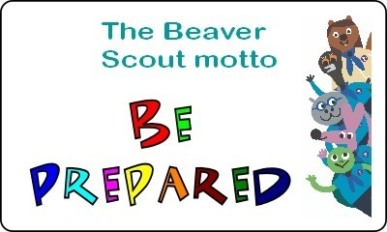
The Beaver Promise is made up of three parts.

To do my Best
It is important to always do your best, even when things are hard or you find them difficult. Can you think of something that you find difficult but you still do your best?

_____________________________________________________________

_____________________________________________________________
To be kind and helpful  Think of five ways that you are kind and helpful. |  | To love my World/ God/ Allah/ Dharma  What do you think this means?
Have a go at matching the badges up with their names
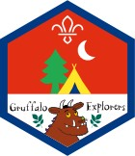
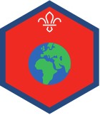
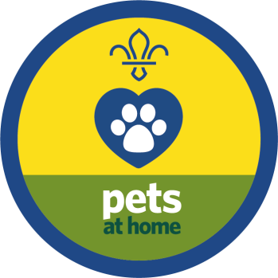
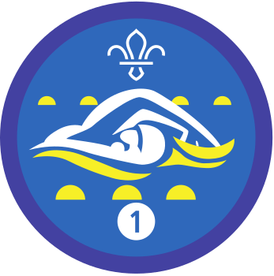
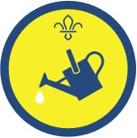
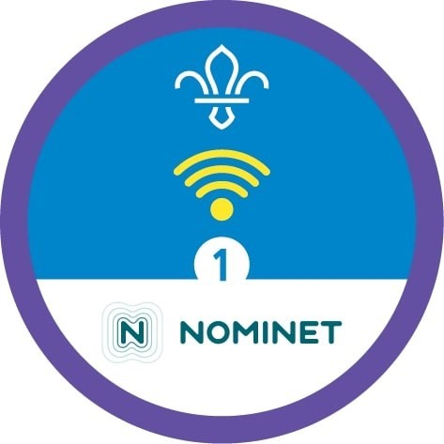
My Outdoors
Digital citizen
Animal Friend
Gardening
My World
Experiment

Swimmer

Beavers are part of the Scouting family. Do you know anyone in one of the other sections?
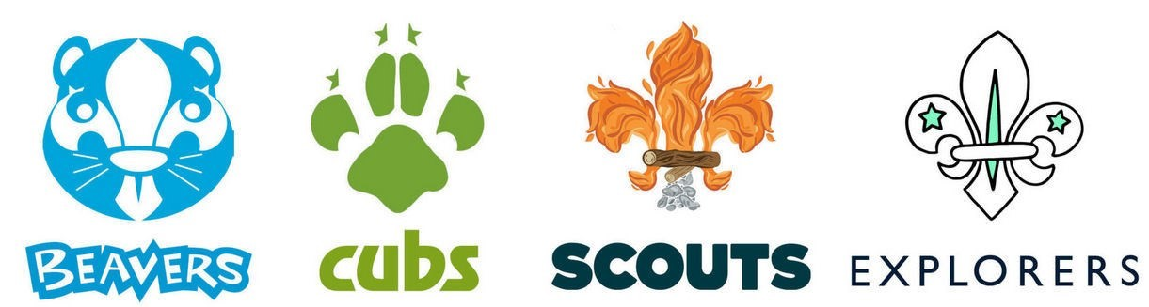

There are scouts all over the world, but they are not always called Beavers, have a go at matching these alternative names to the countries they are from:
Beavers New Zealand
Joeys France
Lutins United Kingdom Meerkats Australia Keas South Africa
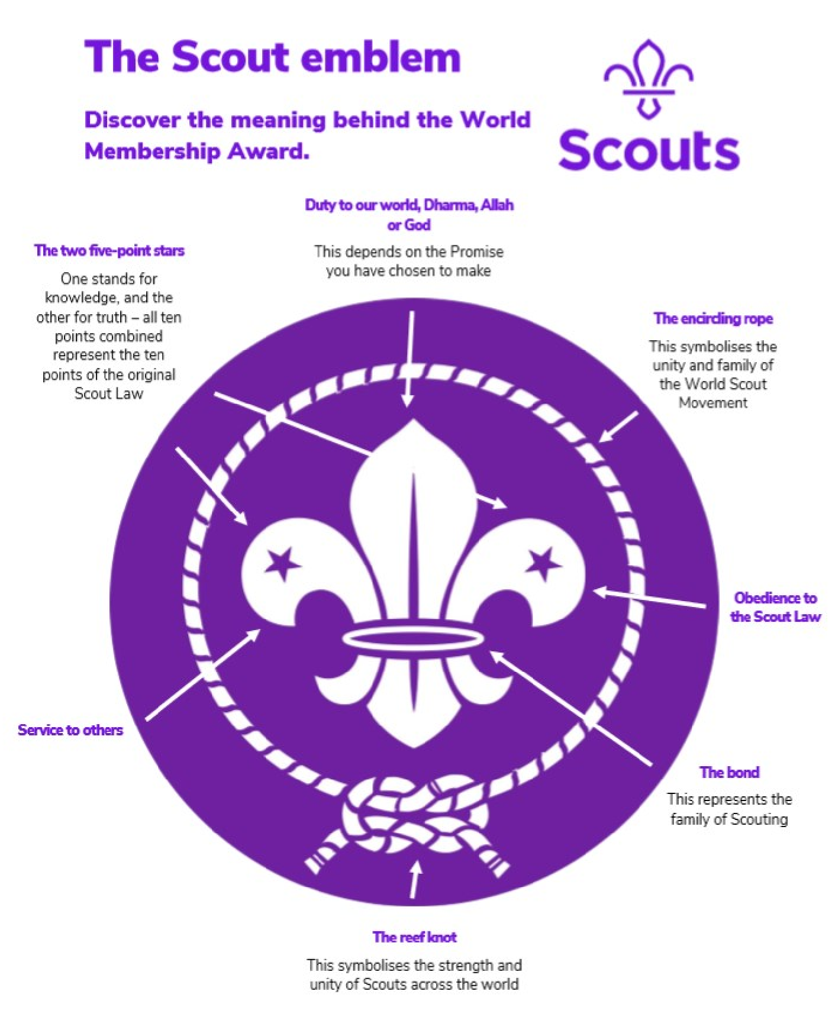
Can you make your own version of the Scout emblem using any resources you wish? This could be a craft or art piece or non-permanent art using items around the home or outside.
Ideas:
3D model using recycled materials
Beach art using pebbles and shells
A drawing using pencils
Digital art using ICT
You can be as creative as you would like.

18th Truro Beavers meets on a Tuesday evening (during term time)
5.30pm - 6.45pm
Chatter - bsl@18thtruro.org.uk
To find out more about Beavers and look at the badges that they can work towards visit https://www.scouts.org.uk/beavers

